**Topics: Descriptive Statistics and Probability**

1. Look at the data given below. Plot the data, find the outliers and find out $μ, σ, σ^{2}$

|  |  |
| --- | --- |
| **Name of company** | **Measure X** |
| Allied Signal | 24.23% |
| Bankers Trust | 25.53% |
| General Mills | 25.41% |
| ITT Industries | 24.14% |
| J.P.Morgan& Co. | 29.62% |
| Lehman Brothers | 28.25% |
| Marriott | 25.81% |
| MCI | 24.39% |
| Merrill Lynch | 40.26% |
| Microsoft | 32.95% |
| Morgan Stanley | 91.36% |
| Sun Microsystems | 25.99% |
| Travelers | 39.42% |
| US Airways | 26.71% |
| Warner-Lambert | 35.00% |

Ans:1 mean=.49907/15

=0.3327

Variance = 0.0287157

Std.deviation = 0.16945

Morgan Stanley is the outlier in the box plot and you can see the outlier in below histogram plot

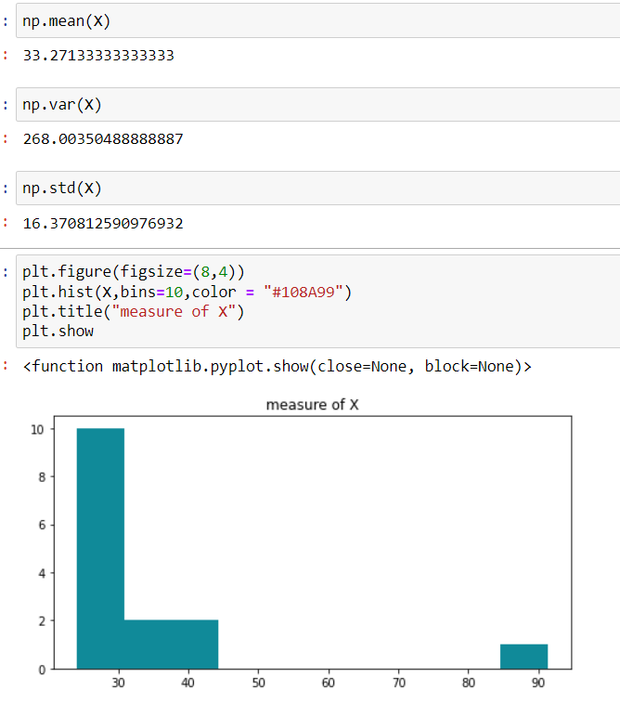



Answer the following three questions based on the box-plot above.

1. What is inter-quartile range of this dataset? (please approximate the numbers) In one line, explain what this value implies.
2. What can we say about the skewness of this dataset?
3. If it was found that the data point with the value 25 is actually 2.5, how would the new box-plot be affected?

Ans:2 (i) Inter-quartile range= (12.5-5)

=7.5

This IQR value measure the spread of the middle half of the data points.

(ii) Box plot is right skewed (Positive skewed) because the longer part of the data set lies to the right the median.

(iii)All the data points values get changed i.e interval is 0.5 and 2.5 is the outlier.



Answer the following three questions based on the histogram above.

1. Where would the mode of this dataset lie?

Ans: Mode of this dataset lies at 6.

1. Comment on the skewness of the dataset.

Ans: Right skewed dataset

1. Suppose that the above histogram and the box-plot in question 2 are plotted for the same dataset. Explain how these graphs complement each other in providing information about any dataset.

Ans: In case of histogram the right skewed plot will obtain and most of the data points lie on

the left side and mean value will be larger than median of the data set. If we talk about box plot the median is closer to the bottom of the box and whisker is shorter on the lower end of the box so it is

right skewed.

1. AT&T was running commercials in 1990 aimed at luring back customers who had switched to one of the other long-distance phone service providers. One such commercial shows a businessman trying to reach Phoenix and mistakenly getting Fiji, where a half-naked native on a beach responds incomprehensibly in Polynesian. When asked about this advertisement, AT&T admitted that the portrayed incident did not actually take place but added that this was an enactment of something that “could happen.” Suppose that one in 200 long-distance telephone calls is misdirected. What is the probability that at least one in five attempted telephone calls reaches the wrong number? (Assume independence of attempts.)

Ans: let us considered the probability of 1 call misdirected out of 200 as event A

Probability of occurring of event A =1/200

P (A) = 1/200

Probability at least one successful call will be= 1- P(A)

= 1 – 1/200

=199/200

=0.967

As every event is independent of other event the probability will be

= 1-(0.967)^5

=0.02475=2% chance

1. Returns on a certain business venture, to the nearest $1,000, are known to follow the following probability distribution

|  |  |
| --- | --- |
| X | P(x) |
| -2,000 | 0.1 |
| -1,000 | 0.1 |
| 0 | 0.2 |
| 1000 | 0.2 |
| 2000 | 0.3 |
| 3000 | 0.1 |

1. What is the most likely monetary outcome of the business venture?
2. Is the venture likely to be successful? Explain
3. What is the long-term average earning of business ventures of this kind? Explain
4. What is the good measure of the risk involved in a venture of this kind? Compute this measure

Ans: (i) As the probability (0.3) is more $2000 as compared to others. Therefore most likely monetary outcome of the business venture is $2000.

(ii) Long term average venture=sum of {P(xi)*Xi}=0.1*(-2000)+0.1*(-1000)+0.2*0+0.2*1000+0.3*2000+0.1*3000

=-200-100+0+200+600+300

=$800 (As it’s a positive no so the business venture likely to be successful)

(iii)Long term average earning of business venture is $800 and which means on an average return will be $800.

(iv)Risk here stems from the possible variability in the expected returns.